Extended Data Modeling and Governance
The extended data structure provides a possibility to accomplish the three interrelated missions. Robust information governance systems benefit due to the ability to provide proactive management abilities the use of a defined set of policies (Hoffer, Venkataraman, & Topi, 2016). Secondly, records governance ensures the continuity of the service due to the potential to provide services to the stakeholders. Lastly, an influential facts governance version deserves because of the reactive control method, which helps a layout supervisor to clear up non-compliance problems. Therefore, the complexity of the statistics and intricate interactions with myriad stakeholders necessitates Amazon to provoke sturdy statistics governance systems.
Nevertheless, statistics modeling is another essential element of database design methodology that serves myriad obligations. The essential responsibilities of a sufficient information modeling are to make specific normalization of a logical database, development of solid design plan, and development of a technical plan that addresses the architectural needs of Amazon’s statistics governance structure (Hoffer et al., 2016). Database modeling the usage of the logical layout includes a transformation of the conceptual necessities for the facts storage the usage of different specs.
The first form of specification focuses on achieving compatibilities with the particular database management device (DAMA International, 2010). The second form of specification concerns with the physical requirement that defines the parameters for the garage to be used as an input element for the implementation of the database (Hoffer et al., 2016). The two models of specifications provide a possibility to understand the Amazon.Com facts requirements and explicit them in an accurate technical language. The subsequent document
addresses the two form of specification because it entails mapping of the conceptual requirement to logical database design, development of physical database design, and development of the commensurate technical plan.
Mapping the Conceptual Requirements to a Logical Database Design
Development of logical design involves the transformation of the Enhanced Entity-Relationship (EER) model to represent complex data governance. An EER model is a reliable tool used to represent the conceptual requirements of an organization (Hoffer et al., 2016). Accurately, an EER model depicts the cadres of super-type and subtype relationships that exist among the data constructs (Loudon & Loudon, 2014). A super-type construct represents the general entity data that contains inheritable attributes (ibid). Subsequently, the subtypes are the specialized data entity that inherits the multiple attributes of a general super-type (Hoffer et al., 2016). The entity clustering process becomes an essential process because it integrates a hierarchical decomposition of the hundreds of entities to create an EER model (ibid). Therefore, the ability to group the existing entities and relationships using hierarchical decomposition merits because it facilitates a design manager to accord attention to essential details of the model. Chart 1 below is a model of EER that depicts the primary attributes and relationships of the super-types and subtypes data constructs for the Amazon.com, Inc.
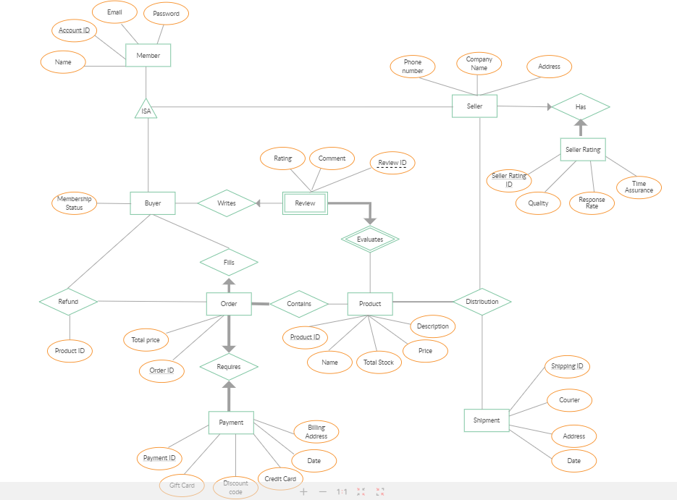
The relational table above illustrates the types of relationship that exist among the CUSTOMER, SUPPLIER, SHIPPER, PRODUCT, and ORDER. The boxes depict the five entities with the line used to demonstrate the type of relationship (Loudon & Loudon, 2014). A one-to-many type of relationship entails a line connecting two entities, which end with a crow’s foot topped by a short mark (ibid). A one-to-one relationship is another common type of relationship between entities that entails line that ends in two short marks (ibid). The goal of identifying the five entities and respective relationships is to influence the understanding of the data to construct for the Amazon.com, Inc. (ibid). Moreover, the relationship and data entities affect the effectiveness of relational, logical data modeling. The tables below reveal the relational database defined from the EER Model

OLAP Database Architecture

The share-nothing version additionally introduces an unavoidable downside of sharing: The records spreading out on one of a kind database shards is separated. The question to read or be a part of facts from a couple of database shards must be mainly engineered. It normally incurs a better latency than its peer that runs on most effective one shard. The incapability to offer a consistent, global photograph of all records limits the shared database architecture in playing a lively function inside the online analytic processing (OLAP) surroundings, where facts analytic capabilities are typically completed on the entire dataset. In an internet transaction processing (OLTP) environment, wherein the great extent of writes or transactions can pass past the capability of a single database, and scalability is of problem, sharing is continually really worth pursuing. With the advent of Amazon RDS, database setup and operations were automatic to a large extent. This makes running with a shared database structure a far easier venture. Amazon RDS offers a fixed of database engines, such as Amazon RDS for MySQL, PostgreSQL, SQL Server, Oracle, MariaDB, and Amazon Aurora. You can use anybody of these as the constructing block for a database shard inside the shared database structure.

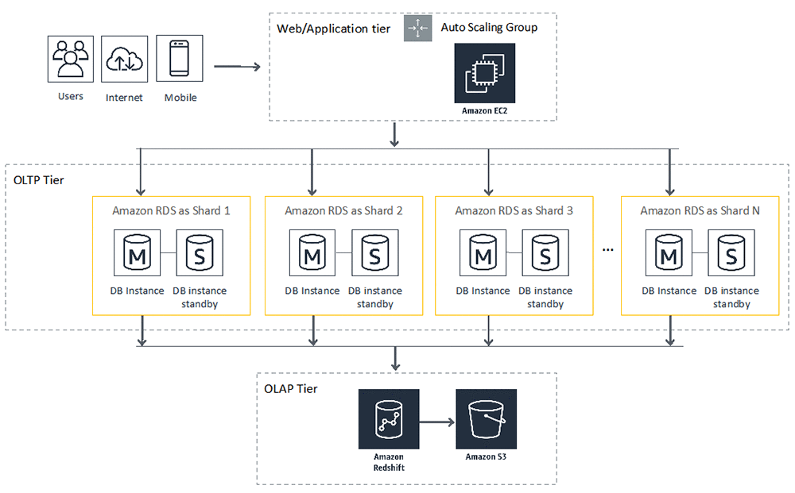
Data Partitioning and Schema Design
The major requirement in implementing a shared database architecture is to partition statistics horizontally and distribute data walls throughout database shards. You can use various techniques to partition a table, including list partitioning, variety partitioning, or hash partitioning. You can permit each database shard to accommodate one or more table partitions inside the format of separate tables. The following diagram is an instance of horizontal partitioning within the Invoice desk with customer_id as the partition key.

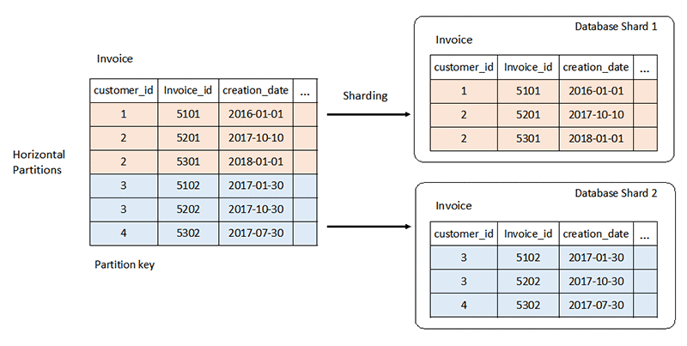

When a couple of tables are concerned and certain via foreign key relationships, you could achieve horizontal partitioning through the use of the equal Partition key on all of the tables concerned. The information that spans throughout tables; however, belongs to 1 partition key is sent to at least one database shard. The following diagram suggests an example of horizontal partitioning in a set of tables

When a couple of tables are concerned and certain via foreign key relationships, you could achieve horizontal partitioning through the use of the equal Partition key on all of the tables concerned. The information that spans throughout tables; however, belongs to 1 partition key is sent to at least one database shard. The following diagram suggests an example of horizontal partitioning in a set of tables

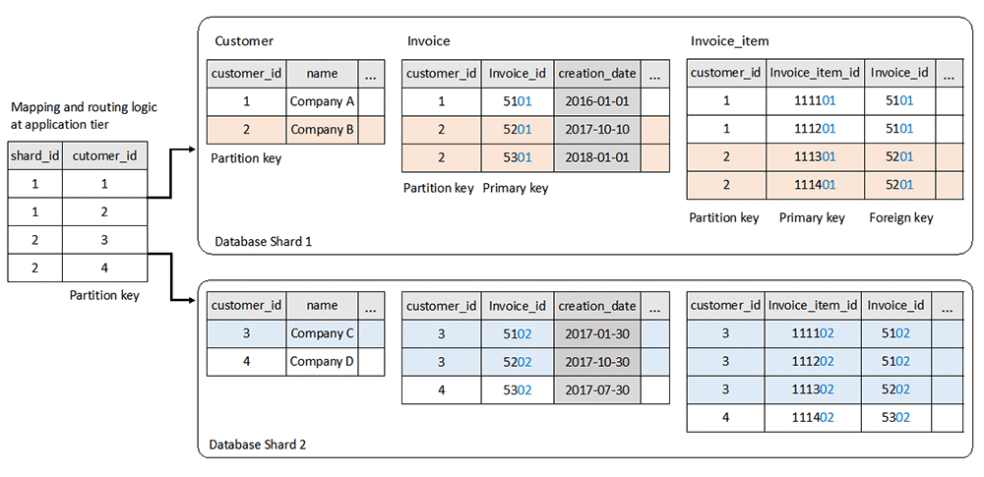
Research on the Data-Type in the DBMS
Amazon Relational Database Service (Amazon-RDS) is a data governance structure used to facilitate the delivery of effective services, which include Amazon Web Services’ cloud-computing services. Amazon RDS structure merits as an architecture platform because of the ability to support multiple data types to meet the different needs of the consumers (Loudon & Loudon, 2014). The common types of relational database services available include the MYSQL, SQL Server, and Oracle Database (ibid). Diversification of the caliber of data type supported in Amazon RDS improves the quality and capability of the database management system (DBMS).
Specifically, the Amazon RDS is a model of relational database architecture appraised because of the ability to accomplish three operations. The critical data development operations include the select, join, and project, which is useful in the development of multiple sets of data (Loudon & Loudon, 2014). The three operations also determine the data type for the entire attributes identified in the Amazon RDS database. First, the select operation is concerned with the creation of a subset that contains the records that meet the defined criteria (ibid). The select operation creates the subset of the rows attributes as per the set standards. Secondly, the join operation facilitates a designer to combine the relational tables and yield more information. Lastly, a project operation facilitates the creation of a subset of the column in a table that meets the specification of the users. Therefore, the three operations specify the cadres of specification and generalization of the types of data structure supported in the Amazon RDS system. Notably, the Amazon RDS is designed in such a manner as to support the relational-based data types found in conventional DBMS and engines.
Physical Design Decision for the Amazon.com
Besides analyses to determine the conceptual requirements and logical design, another element that necessitates decision-making is a physical design model. A physical design influences the arrangement of the database on the storage devices, which are accessible to the users (Loudon & Loudon, 2014). The core aspects of decision-making include designing fields, de-normalization elements, partitioning, and file organization (Hoffer et al., 2016). The four elements of decision-making that relate to physical database design influence the storage format instruct the DBMS about the group attributes and enhance the querying performance.
First, a physical database design focuses on the designing field as a critical element that influences the mapping capabilities. The designing field aspect entails decisions that concern with the mapping of the attributes of the data in a logical database model using a coding schema (Hoffer et al., 2016). The type of coding schema that a designer integrates hinges on the DBMS to harness the compatibility of the designing fields. A notable designing field evident in an MS Access caliber of DBMS is the use of NUMBER FIELDs to represent the use of single field-size, double field-size, or text (ibid).
Secondly, the de-normalization aspect of physical database design has a goal to improve the processing performance of Amazon RDS. Hoffer et al. (2016) define de-normalization as a process of undoing the normalized relation to form a non-normalized physical record (2016). De-normalization is applicable when the entities have a one-to-one of many-to-many types of relationship. Thirdly, partitioning is another aspect of physical database design that facilitates a designer to integrate a horizontal-based or vertical-oriented mapping of the rows and columns respectively in relational, logical modeling. Partitioning aims to redistribute the rows or columns into distinctive physical records.
Lastly, a decision to enhance the physical database design relates to file organization to arrange the partitioned records in a physical storage module. The file organization aims to bolster the speed of retrieving files, processing and maximize the storage spaces (Hoffer et al., 2016). Multiple approaches used to enhance file organization include sequential file access, indexing, and hashed filing (ibid). Specification on the positioning of a file is a strategic decision that improves the use of storage space in a DBMS.

Screenshot Evidence of the Implementation of the Database
Figure 2 below reveals the use of MS Access, which represents a rudimentary tool to display relational-base data.
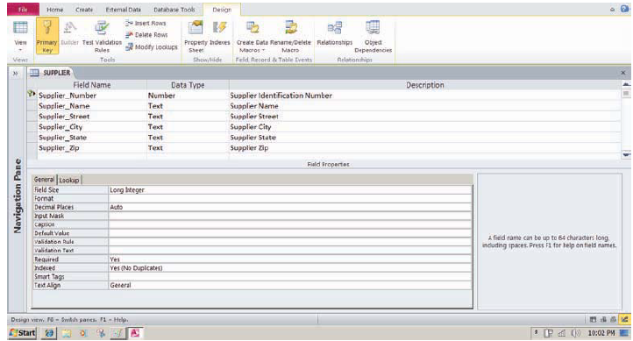

References
DAMA International. (2010). The DAMA Guide to the data management body of knowledge (DAMA-DMBOK), First Edition. New Jersey: Technics Publication
Hoffer, J., Venkataraman, R. & Topi, H. (2016).Modern database management,(12th Edition), New York: Pearson
Loudon, J. & Loudon, K. (2014). Management Information System: Managing Digital Firm, (13th Ed.), Boston; MA, Pearson

